For an accuracy versus defense round consisting of two normal attacks, the standard deviation is always 16; the variance is thus 256. In each direction, rolls range from the clamps of [1,acc+100] and [1,def+69].
We can closely approximate the expected value of each random variable and thus calculate the probability that one random variable is greater than another (that "X wins the roll against Y") with a standardized normal distribution, ignoring the clamped aspect because .
The means for A and B's rolls are thus:
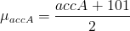, 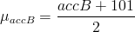
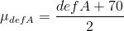, 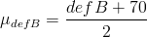
Then using the above procedure to obtain P[X<Y], we yield
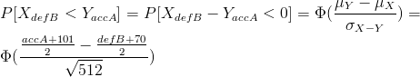.
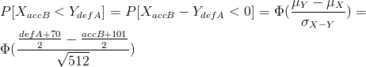.
This considers normal attack v. normal attack, but could also work for special v. normal if you add the special's inherent accuracy to the proper accuracy mean. To exhaust all possibilities, just do the same thing with special v. special, where the mean is {accuracy + move's inherent accuracy + initiative + 101}/2. You can factor in tactics by applying the bonus to the values pre-calculation.
And then, using your opponent's expected loadout, clothing, martial arts stance(s), special sequence, tactic(s), etc. to figure out his/her accuracy and defense values, write a program that cycles through YOUR possible loadouts, outfits, stances, specials, and tactics, and find the one that maximizes the probability of you winning normal v. normal, normal v. special, special v. normal, and special v. special -- multiply those probabilities together and take the maximum.

